**SORTING REFERENCES**

1. In-place sorting algorithm:

- **use constant extra space** for producing the output

- For instance, Intertion Sort and Selection Sort

2. Internal sorting and External sorting

|  |  |  |
| --- | --- | --- |
|  | Internal sorting | External sorting |
| Definition | - **All data** sorting is **placed in-memory** | - all data that needs to be sorted can not be placed in-memory at a time. |
| Examples |  | - Merge sort and its variations  - Hard-disk, CD, etc is used external sorting |

3. Stable sorting:

- **2 objects with equal values appear in the same order** in sorted output (order such as **indexes** in the input array)

4. Bubble sort:

- Idea: how to **put the maximum / minimum value to the leftmost corner** by **swapping the two consecutive** elements => After doing that work, this element sorted.

- Code for implementing the Bubble sort:

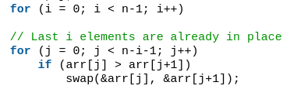

- How to improve:

Based on **swapping the 2 adjacent elements which are not in order** => If there is no elements swapping in the loop, break instantly.

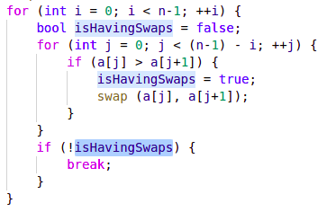

5.